CLASS PROJECT REPORT

Student Name: FEMI-JOSEPH GOLD ISRAEL

Matric No: 241201012

1. Project 1: Mathematical Calculator (MC)
Description
A simple terminal calculator that runs continuously until the user types OFF. It supports basic operations: addition, subtraction, multiplication, division, floor division, exponents, and modulo. It also includes a Clear (C) feature.
Code Logic

Looping: A while True loop keeps the calculator active.

Selections: if-elif-else statements check which mathematical operator ($+, -, *, /, \\, \wedge, \%$) the user typed and perform the correct calculation.

Crash Prevention: try-except blocks stop the program from crashing if a user types text instead of numbers.

Sample Output
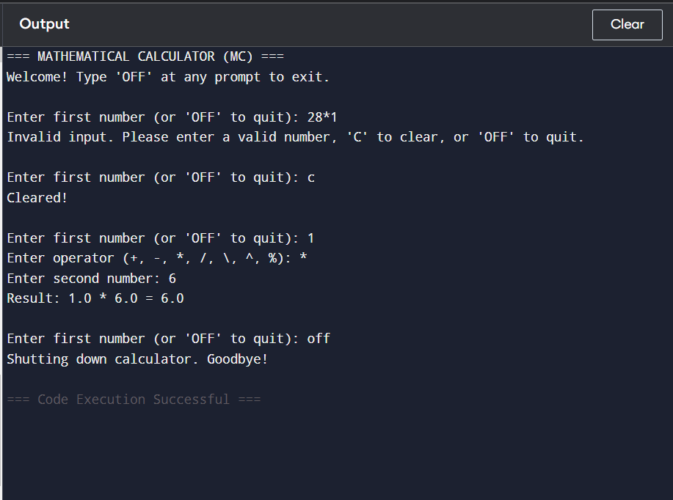

2. Project 2: Personal Pocket CGPA Calculator (PPC)
Description
A portable tool that allows students to calculate their Cumulative Grade Point Average (CGPA) on a 5.0 scale right from their device, instead of logging into academic portals every time.
Code Logic

Nested Loops: Loops through the total number of semesters, and then loops through each course in those semesters.

Grade Selection: Uses if-elif-else statements to convert letter grades to numbers:

A = 5 points | B = 4 points | C = 3 points | D = 2 points | E = 1 point | F = 0 points

Formulae:

$$\text{Course Points} = \text{Credit Units} \times \text{Grade Points}$$

$$\text{CGPA} = \frac{\text{Total Points}}{\text{Total Credit Units}}$$

Class Selection: A final if-elif block checks the final score to print out the student's class degree (e.g., First Class, Second Class Upper).

Sample Output
